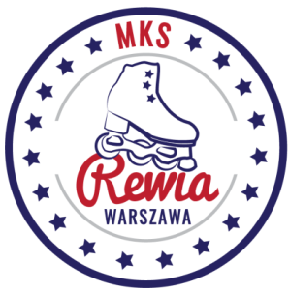

**Planned Program Content (PPC)**

**Christmas Rewia Trophy- Brwinów 2023**

| **Name:** |  |
| --- | --- |
| **Name of the club and country:** |  |
| **Discipline and category:** |  |

| **Elements:** |
| --- |

|  | **Short Program** |  |  | **Free Skating** |
| --- | --- | --- | --- | --- |
| **1** |  |  | **1** |  |
| **2** |  |
| **2** |  | **3** |  |
| **4** |  |
| **3** |  | **5** |  |
| **6** |  |
| **4** |  | **7** |  |
| **8** |  |
| **5** |  |  | **9** |  |
|  | **10** |  |
| **6** |  |  | **11** |  |
|  | **12** |  |
| **7** |  |  | **13** |  |
|  | **14** |  |
| **8** |  |  | **15** |  |
|  | **16** |  |